Tracy Michaels

002430819

System Level Programming Lab 6

Part 1:

Errors -> Correction

Line 1: $#/bin/bash -> #!/bin/bash

Corrected the way to tell which shell to use

Line 3: /\* Check Error Script \*/ -> # Check Error Script

Corrected comment format

Line 10: grep ‘^[^a]\*ce$’ << END >> Result -> grep -E ‘^[^a]\*ce$’ << EOF >> Result.txt

Changed to using extended grep so meta characters are used properly, changed END to EOF for simplicity, changed Result to Result.txt but only to differentiate the file from the first

Line 16: -ENDHERE -> EOF

Changed to EOF to match beginning token

Line 21: ls mail $1 < Result -> mail [$1@student.gsu.edu](mailto:$1@student.gsu.edu) < Result.txt

Removed list command, added domain for email address

Corrected

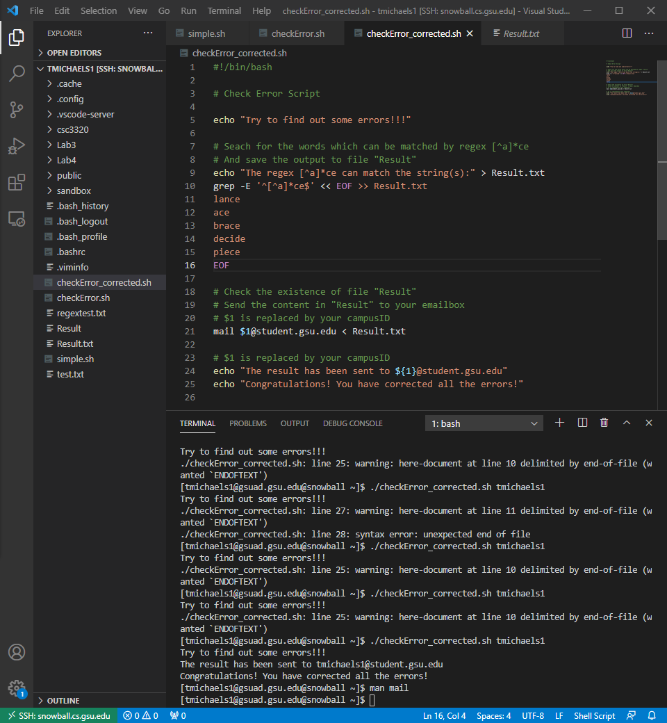

Email received

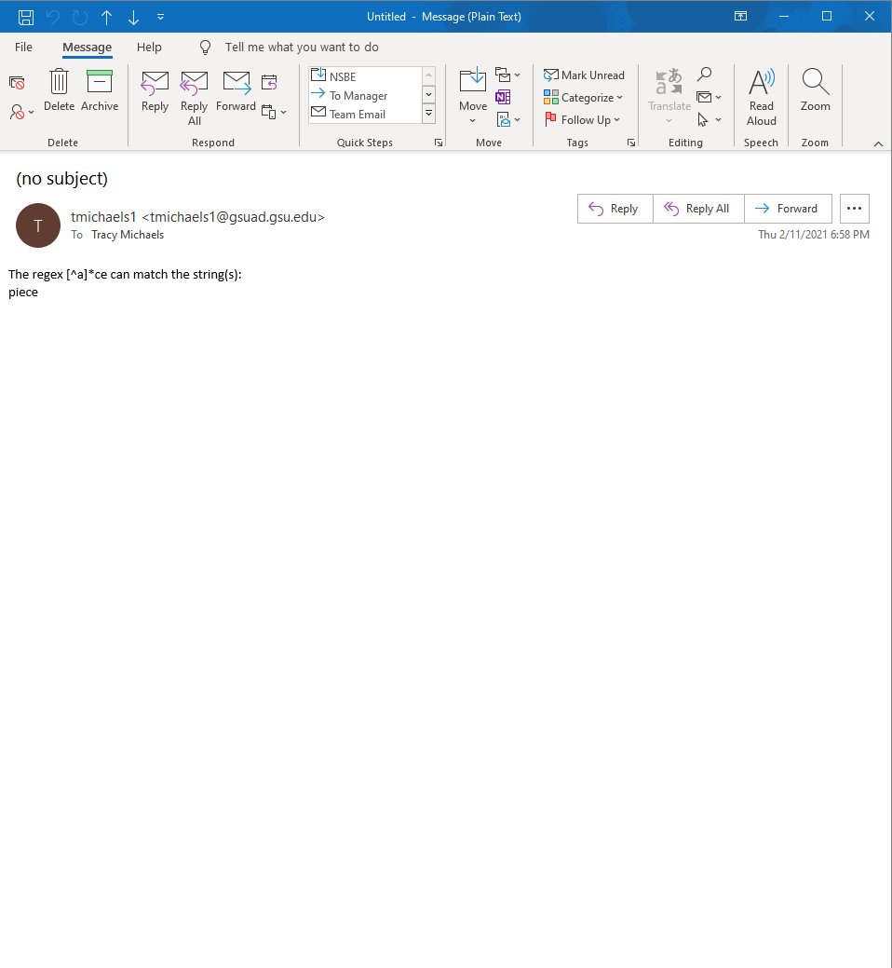

Part 2:

